CodeOrbit: AI Based Programing Language Quiz

Introduction:
Programming skills are essential in today’s technology-driven world. CodeOrbit is a web application that leverages Artificial Intelligence to help users learn and practice multiple programming languages efficiently.
The platform provides AI-generated short notes for each topic and randomized quizzes, allowing users to practice interactively. With adaptive difficulty, hints, and personalized feedback, CodeOrbit ensures an engaging and effective coding learning experience.

Related Works:
Coding Quiz, Python Quiz ,TechQuiz
Idea description:
To build a centralized AI-powered platform that helps users learn and practice programming across multiple languages. CodeOrbit provides interactive topic-wise quizzes, AI-generated notes, and personalized learning paths, making programming practice engaging, adaptive, and effective.

Key features:
Multi-Language Programming Quiz: Users can select different languages like C, C++, Python, Java, and more.
AI-Powered Short Notes: Each topic includes concise AI-generated notes with examples.
Adaptive Quiz System: 10 questions per level, AI randomly generates questions and adjusts difficulty based on user performance.
Topic & Level Structure: Each language is divided into topics and levels for systematic learning.
Progress Tracking: Users can monitor scores, completed levels, and achievements.
Hints & Explanations: AI provides hints and detailed explanations for better understanding.
Technology Stack:
Frontend: NextJs , TailwindCSS.
Backend: Django, FastApi, Supabase.
AI Integration: Ollama
Hosting & Deployment: Vercel.

Workflow of the project:
Maintenance & Updates
Planning & Requirement Gathering
Testing & Deployment
Design & Development

Research similar platforms
Regularly update
Test all features
Design Layout

Deploy the website
Develop the frontend & backend
Choose the technology stack
Gather feedback

Platform:
Web-Based platform with Mobile-Responsive Design.

Project Timeline:
Phase 4
Phase 3
Phase 2
Phase 1

Development
and
Testing
(6 weeks)
Design
and
Prototyping
(3 weeks)
Launch
and
Feedback
(1 week)
Research
and
Planning
(2 weeks)

ER Diagram:-
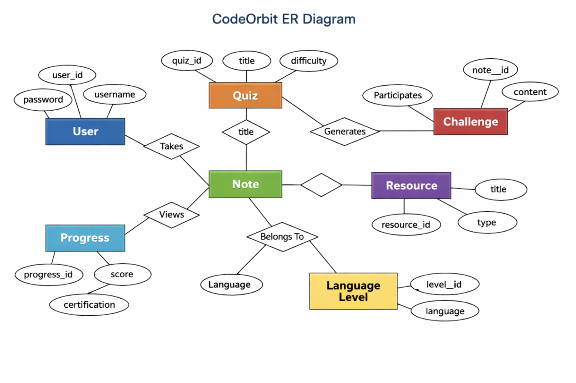

Project Structure:-
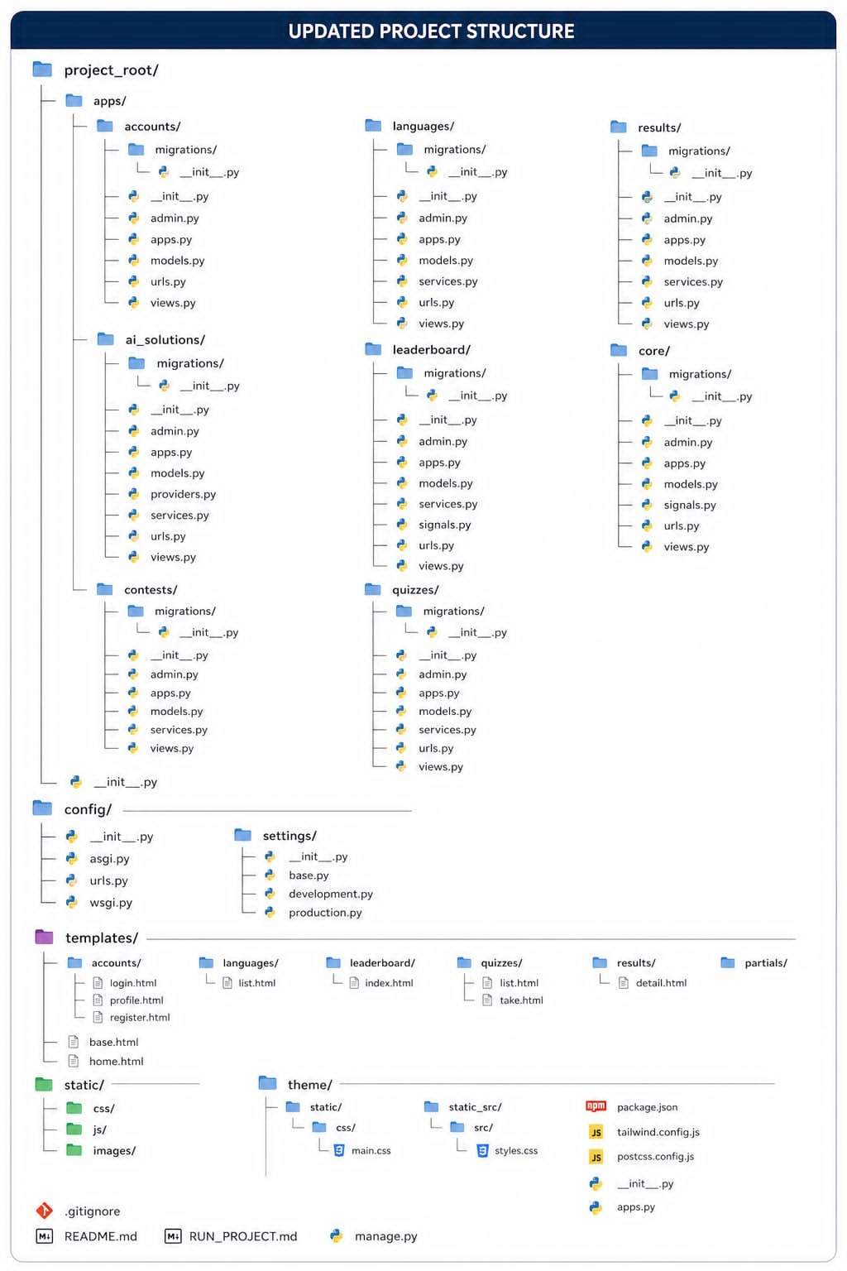

Design:
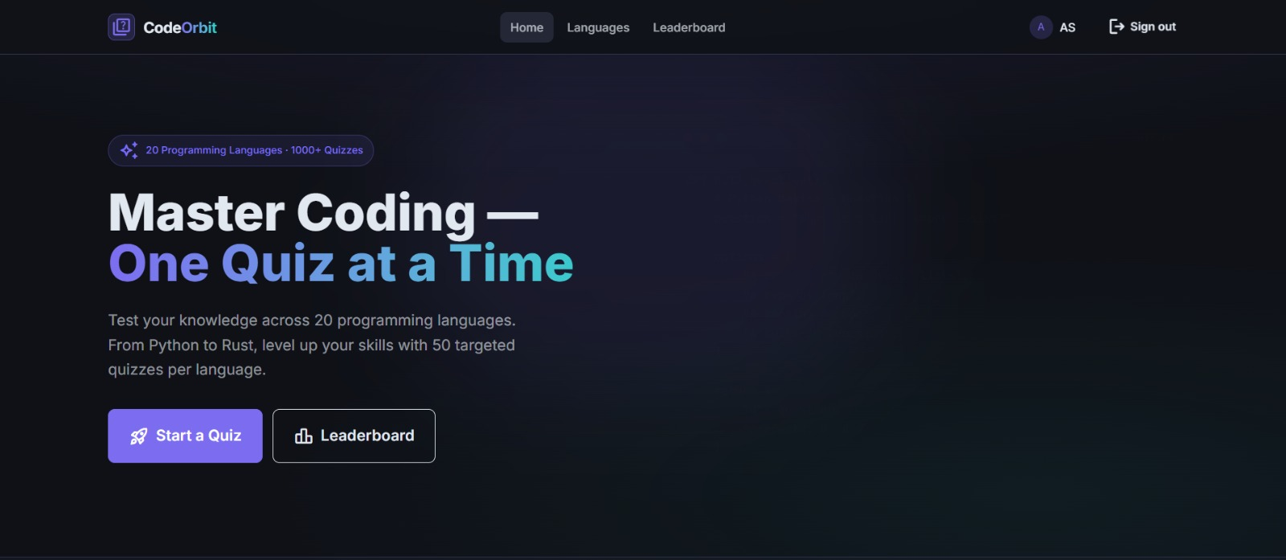
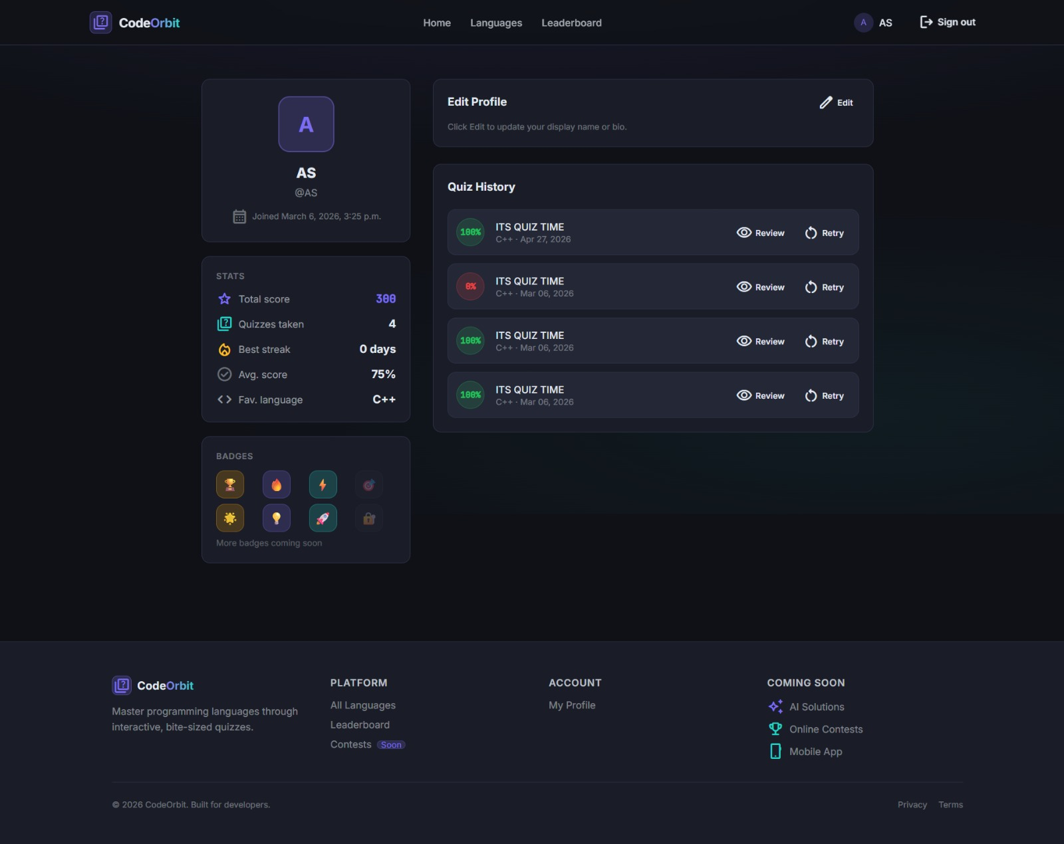
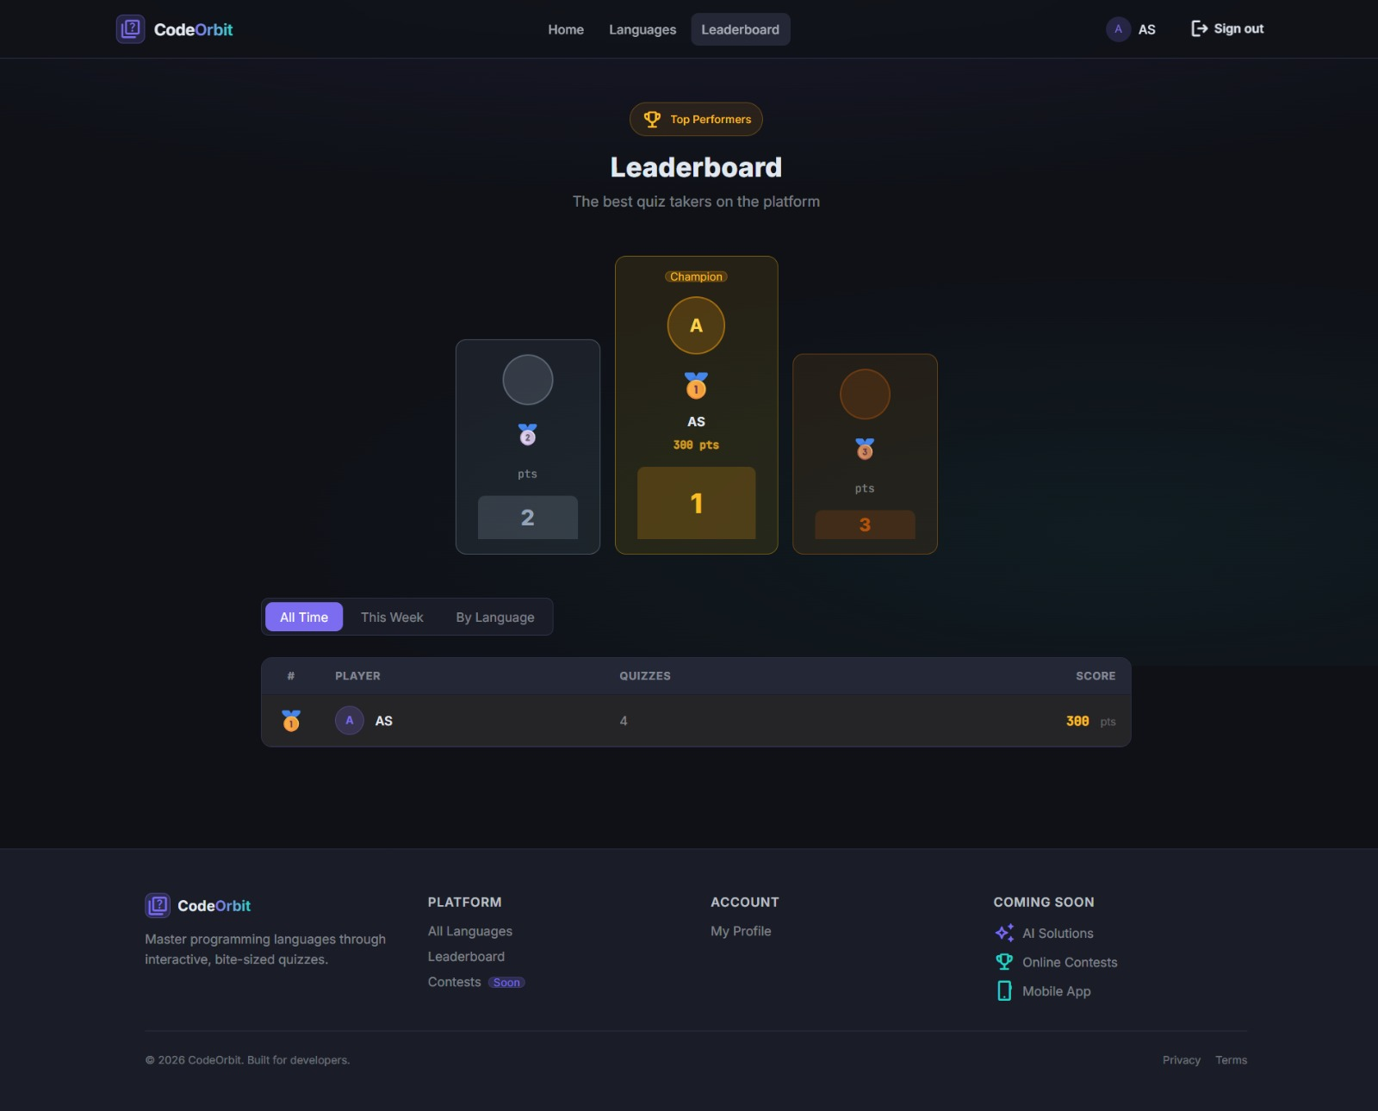

Target population:
- University and college students who want to learn and practice programming.
- Beginner to intermediate programmers seeking structured, topic-wise learning.
- Coding enthusiasts interested in multi-language programming quizzes.
- Individuals preparing for competitive programming, job interviews, or skill improvement.

Social and economical values:
Social value:
- Promotes education and skill development in programming.
- Encourages collaboration and knowledge sharing among students and enthusiasts.
- Bridges the gap for learners in remote areas by providing accessible AI-based learning.
Economic value:
- Reduces the cost of traditional coaching by offering a free or low-cost learning platform.
- Enhances users’ employability by improving programming skills.
- Supports tech skill growth, contributing to a stronger workforce in the IT sector.

Conclusion:
The development of CodeOrbit represents a significant step towards providing an AI-powered learning platform for programming enthusiasts. It offers a centralized space for learning multiple programming languages, practicing quizzes, and receiving personalized AI feedback, ultimately enhancing users’ coding skills and problem-solving abilities.

Limitation: The effectiveness of CodeOrbit depends heavily on user engagement and consistent practice. AI-generated quizzes and notes require continuous updates and monitoring to ensure accuracy. Additionally, integrating multiple programming languages and levels increases the complexity of maintenance and development.

Future Work: In the future, CodeOrbit can introduce team challenges and coding competitions to encourage collaborative learning. The AI-driven resource library can be expanded with more examples, tutorials, and broader language coverage. Cross-platform compatibility can be improved to include mobile apps for wider accessibility. Additionally, gamification elements such as badges, points, levels, and leaderboards can be integrated to make learning more engaging and motivate users to consistently practice and improve their skills. Progress analytics and certification features can also be added to track learning outcomes and achievements.
Summary: CodeOrbit has the potential to positively impact learners by enhancing programming skills, promoting self-paced learning, and providing AI-guided practice. By bridging the gap in accessible programming education, it empowers students and enthusiasts to improve their knowledge, problem-solving ability, and career prospects.

